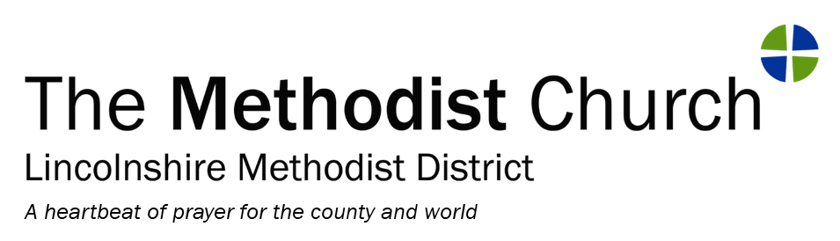

Safeguarding in Lincolnshire District
District Chair: Rev Bruce Thompson 01522 804011
District Safeguarding Officer: Howard Smedley 01636 815319/07758 239286
safeguarding@lincolnshiremethodist.org.uk

LINCOLNSHIRE METHODIST DISTRICT SAFEGUARDING CONFERENCE 2022

Saturday March 5th 2022, on-line keynote speakers:
9.30am to 11.00am – The Theology of Safeguarding
Speaker: The Revd Dr Nicola Price-Tebbutt, Secretary of the Faith and Order Committee for the Methodist Church.
In 2021, Methodist Conference considered the report by the Faith and Order committee on the Theology of Safeguarding and accepted the following recommendation, among many related to it:
27/2. The Conference directs Church Councils, Local Preachers’ Meetings, Circuit Meetings and District Policy Committees to consider the implications of the report for their work and practice
As a District, we are therefore responding to this by having Rev Dr Nicola share with us the overarching themes that look at:
Theological roots ● Abuse and the human condition ● Theological thinking and how it is used ● Failure to challenge inappropriate and unacceptable behaviour and maintain appropriate interpersonal boundaries ● Welcoming people who have experienced abuse
● Grappling with power ● Forgiveness and change

11.30am to 1pm – Trauma and Pastoral Care
Speaker – The Rev Louise Carr, Superintendent Minister of the Wolds and Trent Methodist Circuit, Lincolnshire Methodist District
Louise writes – “During my last sabbatical I was introduced to the idea of applying trauma theory to Bible study & Pastoral Care in various ways. It was, and is, a relatively new field but I have continued to read & research the concept. In the UK, there is a team of researchers & educators who explore congregational trauma offering resources & concepts to cope with the impacts. Congregational trauma includes a variety of real situations such as the arrest of a leader for sexual abuse, the suicide of a young person who felt rejected by the church theology as a young homosexual and Grenfell Tower.
Last year a publication from one of the researchers encouraged me to think about the traumatic impact on churches, congregations and ministers of the pandemic. As I read and thought through the concepts in the book the idea arose of using insights from this book and from my wider reading to benefit those working in my church. I shared the idea with Howard and here I am. Trauma affects individuals after abuse, or witnessing a traumatic event. Trauma affects communities, think of Grenfell, or witnessing a major traffic accident. In this global pandemic, there is a complex & involved trauma-inducing period, which has extended for 2 years and has involved periods of separation from places of worship. I hope this talk will help to explore resources we have, in our pastoral care, in preparation and in scripture and worship to enable recovery and understanding as we move forward”

2pm to 3.30pm – Responding Well in our support to and understanding of Survivors.
Speaker: Kate Little, Connexional Safeguarding Lead for work with survivors
The Methodist Church is committed to the respect, dignity and value that those who have been hurt by it deserve. The Methodist Past Cases Review is dedicated to survivors/victims of abuse that has occurred within the Methodist Church with the hope that its findings and subsequent actions will contribute to making the church a safer place for all in the future.
This keynote talk will look at some of the things we have learned in making the church that safer place and in responding well.
Kate Little is the Connexional Safeguarding lead for work with survivors and will be leading this session along with others working with her. There is much still to learn and this session will help us to identify some of the key challenges for us, leading in to some of the safeguarding sessions over the following two weeks.

Practicalities
Care and support - In all the above sessions, we are asked to be a community of people learning together, supporting each other in love and being prayerful in our conversations to respect anyone who may be impacted by them. There will be pastoral support, listeners and a Chaplain available throughout the day.
Registration – Please register by sending your name, email address and church to Alison at PA@lincolnshiremethodist.org.uk or by phoning 01522 370126. If you are hoping to join the Zoom on the phone because you don’t have a computer then please phone to book your place.
Follow up safeguarding sessions – these will commence from Monday 7th March – the programme is still being finalised and will reach you in due course. They will follow the model of workshops on Zoom, used previously, but will be based on the three topics covered in these keynote sessions.
Equality, Diversity and Inclusion – Please do let Alison or I know if there is anything we can do to ensure that you are able to participate fully in the sessions and any support you may need to do so.
Time keeping – Each session will open 30 minutes before the start. The sessions will begin on time. This is out of respect for our speakers who are giving up their time and for those who join early. If you are aware that you may be late joining, do please let us know, otherwise we will admit you at a convenient point.
Respecting the Zoom space - this is just a reminder that we will ask everyone who is listening to mute themselves unless needing to speak or raise a question. People should feel free to listen without the use of their video on if preferred.
Recording – it is hoped to record the Saturday talks so that they can be available after the session, probably via the District website. If you do not wish to be recorded then please ensure that you switch off your video before the recording starts.
Safeguarding – Howard will be at the sessions and so will deal with any safeguarding issues that occur or any help that you need. Messages to him by text or call will be possible during the sessions.
Joining instructions – The Zoom codes will be sent by email nearer the time. The same Zoom code will be used for each of the three sessions.

