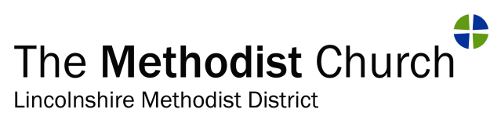
Project Evaluation

Monitoring and Evaluation of Grants

The following information is required to assist with monitoring and evaluating the impact of a District Advance Fund Grant.

When responding the spaces between questions is expandable.

Please return this form by email to the District Office at pa@lincolnshiremethodist.org.uk

Church/Circuit/District/Ecumenical Group name:
Correspondent Name: | Position held:
Tel. No. | E- mail:

A - Project Summary:

Project Title:
Amount of grant received:

Is this report: after 1 year / after 3 years / upon completion (for a property project)

(please circle)

B – Evaluation Questions

- Please provide a clear statement that summarises what you have achieved and how you went about it. If objectives were not met, please explain why.

- Have you/did you make any changes to your objectives? If so, why and what are the new objectives?

- What aspects of your project or new activities/ventures are still being developed, and when do you expect to start these?

- How is the project impacting on the local community?

- For ecumenical projects please comment on the impact this project has had on ecumenical relationships.

- Please let us know of any issues that are affecting the timescales for this project and steps being taken to mitigate the issues.

- Is there anything that you have learned to date which would be useful to share with others considering similar work with grant assistance from the District Advance Fund?

C - Financial Aspects of the project

- Please include a statement of income and expenditure for the project showing actual against budget/estimates. If you anticipate the work continuing beyond the current funding arrangements how will this work be funded?

Date of Report: __________________

Please return this form to the District Office by email to pa@lincolnshiremethodist.org.uk

